| Experiment No.3 |
| --- |
| To implement the concept of Merkle root |
| Date of Performance: |
| Date of Submission: |

**AIM:** To implement the concept of Merkle root

**Objective:** To develop a program to create a cryptogrphich hash using the concept of merkle tree

# Theory:

A Merkle tree stores all the transactions in a block by producing a digital fingerprint of the entire set of transactions. It allows the user to verify whether a transaction can be included in a block or not.

Merkle trees are created by repeatedly calculating hashing pairs of nodes until there is only one hash left. This hash is called the Merkle Root, or the Root Hash. The Merkle Trees are constructed in a bottom-up approach

Every leaf node is a hash of transactional data, and the non-leaf node is a hash of its previous hashes. Merkle trees are in a binary tree, so it requires an even number of leaf nodes. If there is an odd number of transactions, the last hash will be duplicated once to create an even number of leaf nodes.

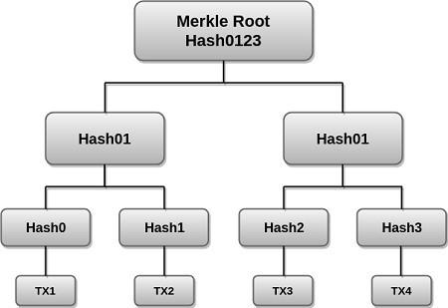

Fig.3.1 Merkle Root Tree Structure

The above example is the most common and simple form of a Merkle tree, i.e., Binary Merkle Tree. There are four transactions in a block: TX1, TX2, TX3, and TX4. Here you can see, there is a top hash which is the hash of the entire tree, known as the Root Hash, or the Merkle Root. Each of these is repeatedly hashed, and stored in each leaf node, resulting in Hash 0, 1, 2, and

3. Consecutive pairs of leaf nodes are then summarized in a parent node by hashing Hash0 and Hash1, resulting in Hash01, and separately hashing Hash2 and Hash3, resulting in Hash23. The two hashes (Hash01 and Hash23) are then hashed again to produce the Root Hash or the Merkle Root.

Merkle Root is stored in the block header. The block header is the part of the bitcoin block which gets hash in the process of mining. It contains the hash of the last block, a Nonce, and the Root Hash of all the transactions in the current block in a Merkle Tree. So having the Merkle root in block header makes the transaction tamper-proof. As this Root Hash includes the hashes of all the transactions within the block, these transactions may result in saving the disk space.

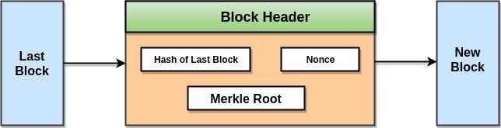

Fig.3.2 Merkle Root in Block

The Merkle Tree maintains the **integrity** of the data. If any single detail of transactions or order of the transaction's changes, then these changes reflected in the hash of that transaction. This change would cascade up the Merkle Tree to the Merkle Root, changing the value of the Merkle root and thus invalidating the block. So everyone can see that Merkle tree allows for a quick and simple test of whether a specific transaction is included in the set or not.

# Process:

Step 1. The transaction represents the original data blocks which are hashed to produce transaction hashes (transaction id) which form the leaf nodes.

Step 2. The leaf nodes have to be even in number for a binary hash tree to work so if the number of leaf nodes is an odd number, then the last leaf node is duplicated to even the count.

Step 3. Each pair of leaf nodes is concatenated and hashed to form the second row of hashes. Step 4. The process is repeated until a row is obtained with only two hashes

Step 5. These last two hashes are concatenated to form the Merkle root.

# Conclusion:

In conclusion, implementing the concept of Merkle root in a system or application offers several key advantages. It provides a secure and efficient way to verify the integrity of data, particularly in blockchain and cryptographic applications. By organizing data in a hierarchical structure and hashing it into a single root value, Merkle trees enable quick and reliable verification, reducing the risk of tampering or data corruption. This concept has found widespread use in various industries, ensuring data security and trustworthiness in a wide range of applications. As technology continues to evolve, the Merkle root remains a valuable tool for maintaining the integrity and authenticity of digital data.

CSDL7022: Blockchain Lab

# Output:

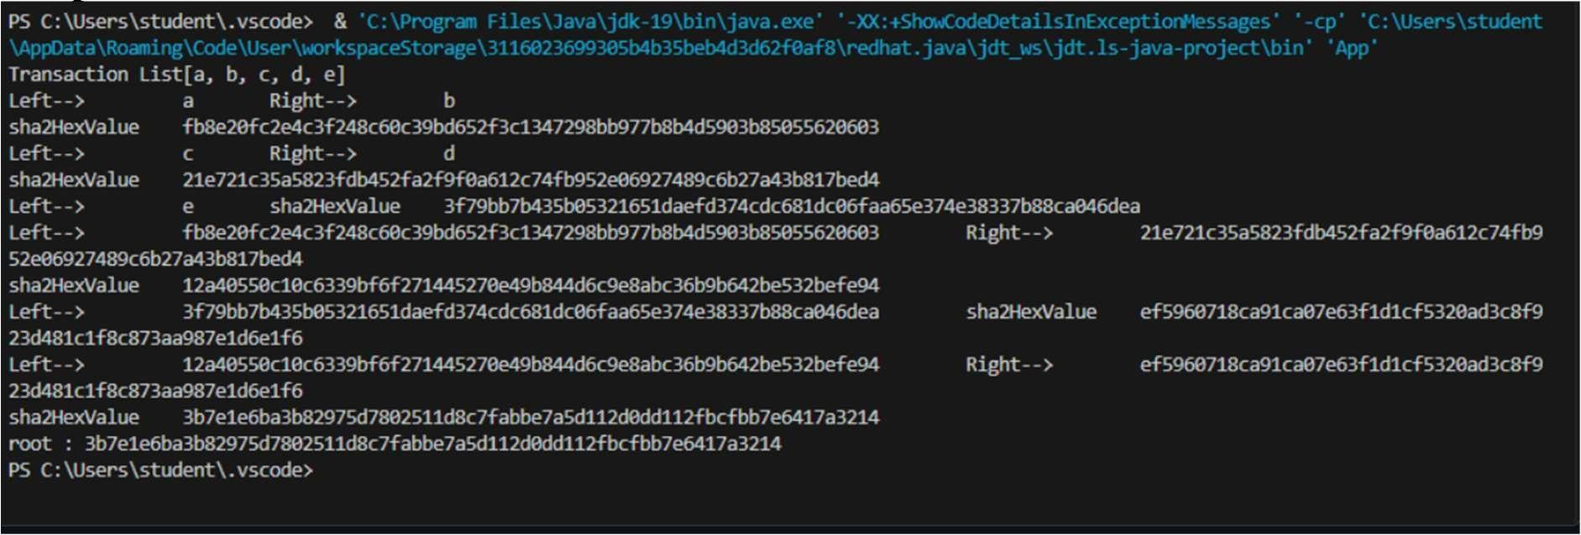

CSDL7022: Blockchain Lab